SmartShip Logistics Management System
Project Requirement Document (Microservices)
Angular • ASP.NET Core Microservices (4) • Ocelot API Gateway • SQL Server • EF Core Code-First • JWT

A) Application Overview
SmartShip Logistics Management System is a web-based shipping and logistics application that enables customers to create shipment requests, calculate shipping rates, schedule pickups, upload shipment documents, and track deliveries in real time. The system supports domestic, international, express, and freight shipping operations. Admin users can monitor shipment movement, handle delivery exceptions, manage hubs and users, and generate operational and performance reports. The solution is built using a microservices architecture with an Ocelot API Gateway to ensure scalability, security, and maintainability.

B) Objective
• Digitize the end-to-end shipment booking and delivery lifecycle
• Improve shipment tracking accuracy and delivery transparency
• Reduce manual coordination through automated workflows and statuses
• Enforce secure role-based access using JWT authentication
• Demonstrate enterprise-ready microservices architecture for logistics systems

C) Roles & Access Control

Mandatory Roles
1) Customer
• Register and login
• Create shipment requests
• Schedule pickup
• Upload shipment documents (invoice, labels)
• Track shipment status and delivery confirmation
2) Admin
• View shipment queues across hubs
• Monitor shipment progress and exceptions
• Resolve delivery issues
• Generate operational and performance reports
• Manage users, hubs, and service locations

Security Implementation
• Angular Route Guards protect /customer/* and /admin/* routes
• JWT Bearer authentication for all backend APIs
• [Authorize(Roles="ADMIN")] enforced on admin endpoints
• All API communication routed through Ocelot Gateway

D) UI Design Architecture (Angular)

Angular Modules
• CoreModule – layout, navigation bar, interceptors, error handling
• SharedModule – reusable tables, status badges, modals, upload components
• AuthModule – login and signup
• CustomerModule – dashboard, shipments, tracking
• ShipmentModule – shipment creation and details
• AdminModule – monitoring, exception handling, approvals
• ReportsModule – charts and exports

Routing (Example)
• /auth/login, /auth/signup
• /customer/dashboard, /customer/shipments, /customer/track/:id
• /admin/dashboard, /admin/shipments, /admin/reports

UI Design Pattern
Chosen Pattern: Wizard / Stepper Pattern
• Used for Create Shipment flow
• Used for Schedule Pickup flow
• Reduces errors by collecting information step-by-step
• Allows save draft and submit after validation

E) Page-by-Page Functional Requirements

1. Landing Page
Purpose: Public entry point for logistics services
UI: Banner, service cards, CTA buttons
API: Optional GET /gateway/shipments/services
Navigation: Create Shipment → Login/Signup

2. Signup Page
Purpose: Customer registration
Fields: Name, Email, Phone, Password
Validations: Email format, password strength
API: POST /gateway/auth/signup

3. Login Page
Purpose: Authenticate Customer/Admin
API: POST /gateway/auth/login
Navigation: Role-based redirect

4. Customer Dashboard
Purpose: Overview of shipments
UI: KPI cards, recent shipments table
API: GET /gateway/shipments/my

5. Create Shipment (Wizard)
Purpose: Create new shipment request
Steps: Sender → Receiver → Package → Review
Validations: Mandatory fields, weight limits
API: POST /gateway/shipments

6. Shipment Details
Purpose: View shipment information
UI: Shipment summary, tracking history
API: GET /gateway/shipments/{id}

7. Upload Documents
Purpose: Upload invoice, labels
Validations: File type and size
API: POST /gateway/tracking/documents/upload

8. Track Shipment
Purpose: Real-time shipment tracking
UI: Timeline view
API: GET /gateway/tracking/{trackingNumber}

9. Delivery Confirmation
Purpose: Proof of delivery
UI: Signature/image view
API: GET /gateway/tracking/{id}/delivery-proof

10. Admin Dashboard
Purpose: Operational overview
UI: Shipment metrics, alerts
API: GET /gateway/admin/dashboard

11. Admin Shipment Monitoring
Purpose: Monitor all shipments
UI: Filters, shipment table
API: GET /gateway/admin/shipments

12. Admin Exception Handling
Purpose: Resolve delayed/failed shipments
UI: Exception list, resolution actions
API: PUT /gateway/admin/shipments/{id}/resolve

13. Admin Reports
Purpose: Performance and SLA reports
API: GET /gateway/admin/reports

14. User & Hub Management
Purpose: Manage users and logistics hubs
API: GET/PUT /gateway/admin/users, /gateway/admin/hubs

F) Status Lifecycle

Shipment Lifecycle
Draft → Booked → Picked Up → In Transit → Out for Delivery → Delivered

Exception States
Delayed / Failed / Returned
Who can change status:
• Customer: Draft → Booked
• Admin/System: Booked → Delivered / Exception
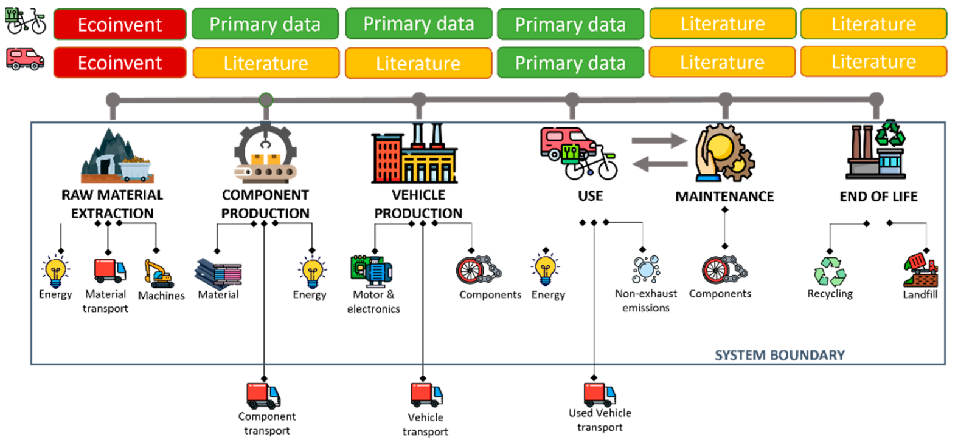
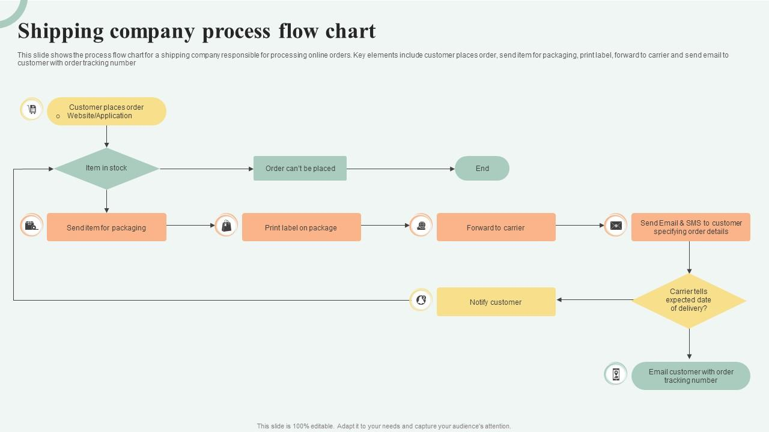

G) Microservices System Architecture (4 Services + Ocelot)
Architecture Flow:
Angular UI → Ocelot API Gateway → Microservices → SQL Server
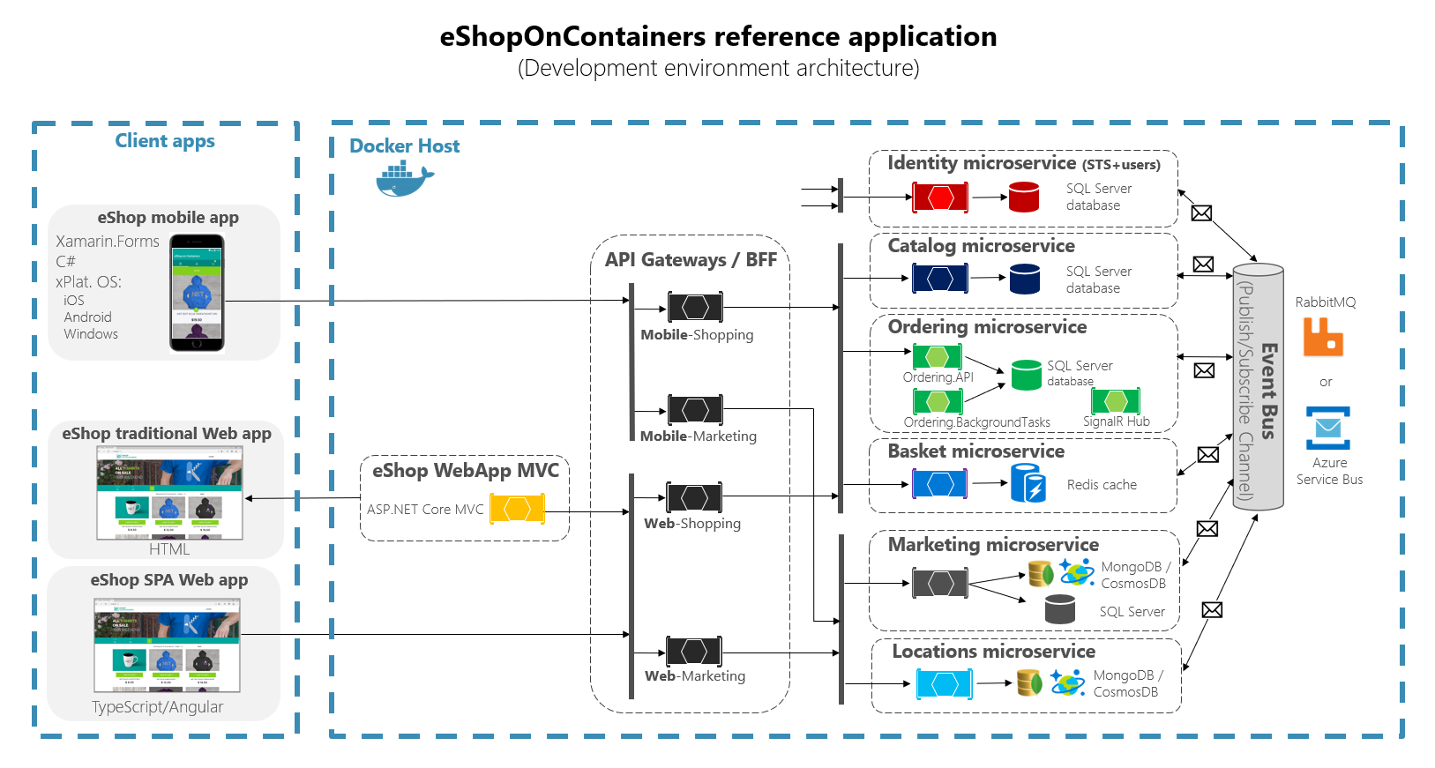
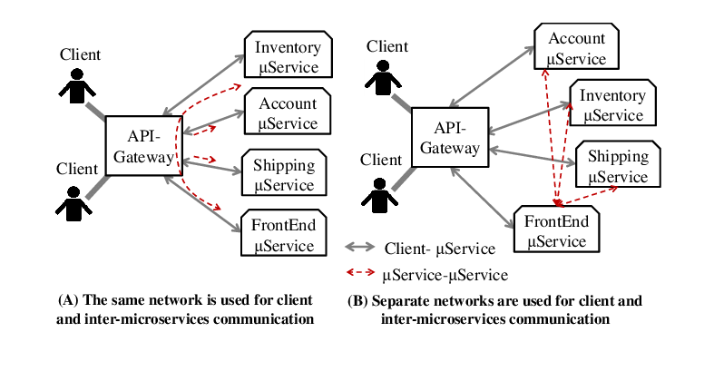

Microservices
- Identity / Auth Service – authentication, JWT, roles
- Shipment Management Service – shipment booking, lifecycle
- Tracking & Documents Service – tracking events, POD
- Admin / Reporting Service – dashboards, reports, exceptions
Optional: Email/SMS notifications for shipment updates.

H) Database Design (SQL Server + EF Core Code-First)

Core Entities
• Users
• Shipments
• Packages
• Addresses
• TrackingEvents
• Documents
• DeliveryProofs
• Reports
Each microservice has its own DbContext and migrations.
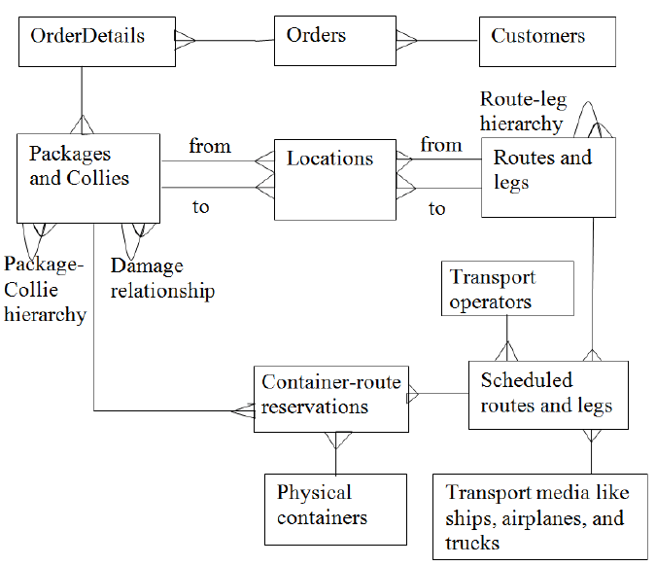

EF Core Code-First Steps
Models → DbContext → Migrations → Update Database → Verify in SSMS

I) REST API Summary (By Service + Gateway)
Gateway Routes
• /gateway/auth/*
• /gateway/shipments/*
• /gateway/tracking/*
• /gateway/admin/*
API Tools: Swagger (documentation), Postman (testing)

J) Software Required
Frontend
• Node.js LTS
• Angular CLI
• VS Code
Backend
• .NET SDK
• Visual Studio 2022
Database
• SQL Server Developer
• SSMS

K) Testing & Quality Plan
Backend (NUnit)
• Service and repository unit tests
• Coverage ≥ 90%
Frontend (Jasmine/Karma)
• Component, service, and guard tests
Quality
• SonarQube / SonarLint
• dotnet

